Ex.No: 6b | DATA VISUALIZATION USING POWER BI

AIM:
To import, transform, analyze, and visualize data using Power BI Desktop and create interactive dashboards and reports for decision-making..

ALGORITHM 1:
Importing Data into Power BI
Step 1: Open Power BI Desktop
Step 2: Select: Home → Get Data
Step 3: Choose CSV
Step 4: Browse dataset and select it

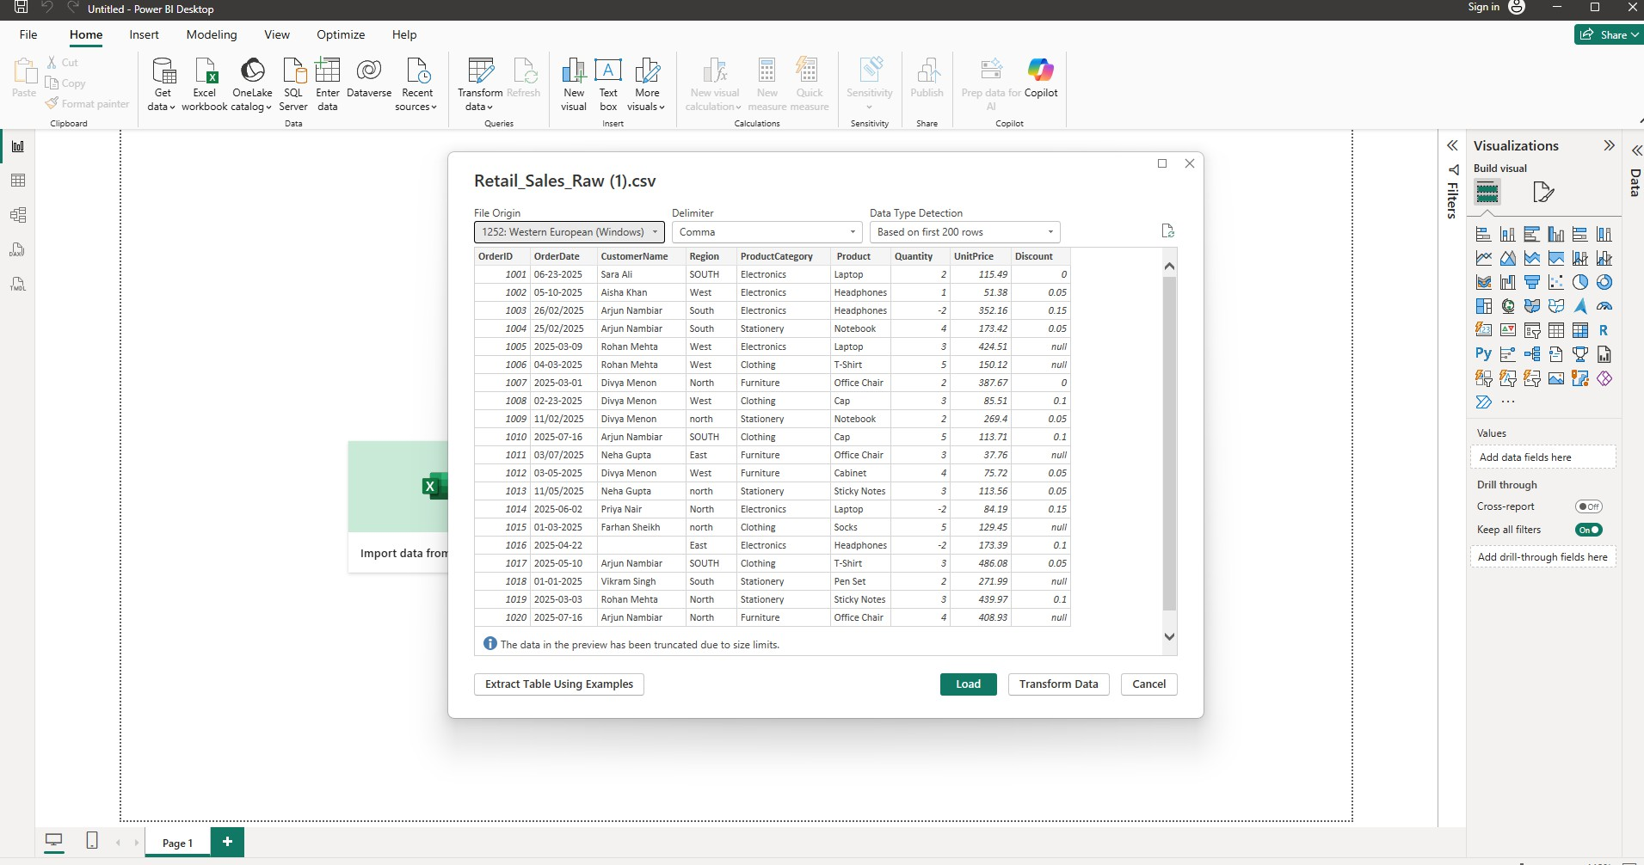

ALGORITHM 2:
Data Transformation using Power Query
Step 1: Select Transform Data
Step 1: Open Power Query Editor.
Step 3: Remove duplicates
Step 4: Handle null values
Step 5: Rename columns
Step 6: Apply changes.
PROCEDURE:
- The data preview window will appear. Select Transform Data instead of Load to open the Power Query Editor.
- In the Power Query Editor, examine the imported table and verify that all required columns are present, such as OrderID, OrderDate, CustomerName, Region, Quantity, UnitPrice, and Discount.
- Remove blank rows from the dataset by selecting Home → Remove Rows → Remove Blank Rows. This removes completely empty records that could interfere with analysis and calculations.
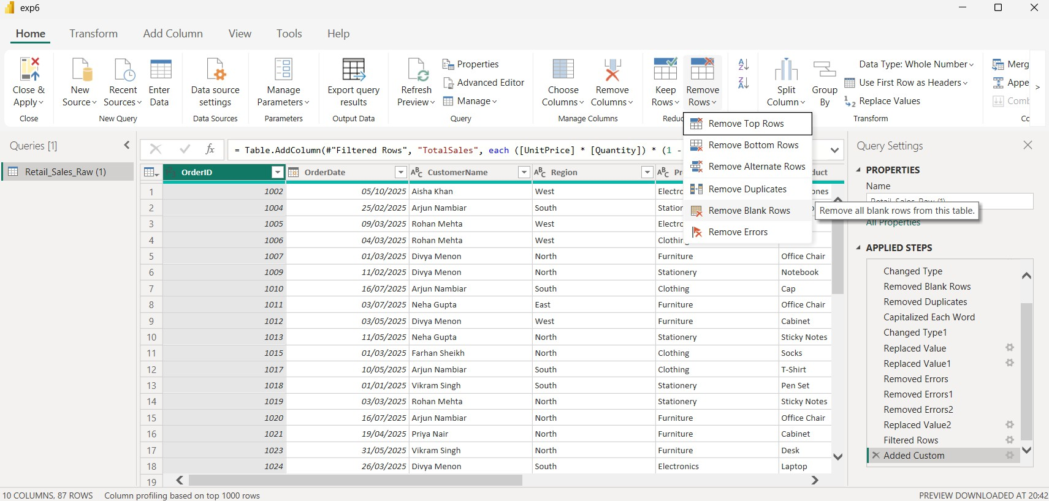
- Remove duplicate records by selecting all columns in the table using Ctrl+A on the column headers and choosing Home → Remove Rows → Remove Duplicates. Power Query will remove records that contain identical values across all selected columns.
- Standardize the values in the Region column. Right-click the Region column, select Transform, and choose Capitalize Each Word. This ensures that values such as “north”, “North”, and “NORTH” are represented consistently as “North”.
- Standardize the OrderDate column by selecting it and choosing Transform → Data Type
→ Date. If Power Query displays errors because the dates use an inconsistent format, right-click the OrderDate column, select Change Type → Using Locale, and choose the appropriate date format and locale.
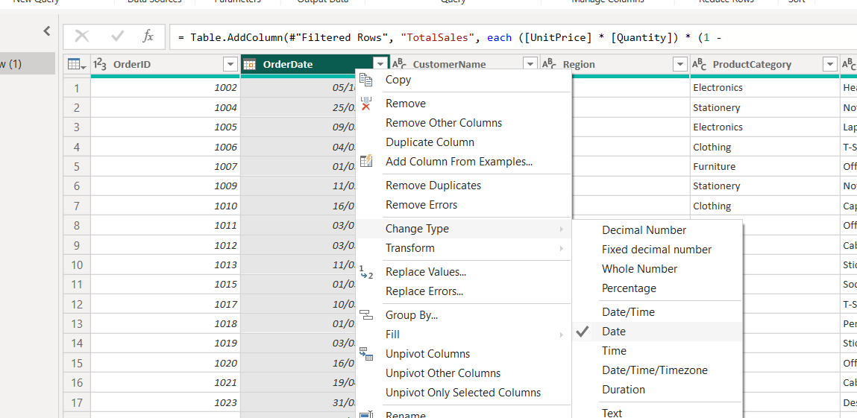

- Handle missing values in the CustomerName column. Right-click CustomerName, select Replace Values, and replace blank or null values with “Unknown Customer”.
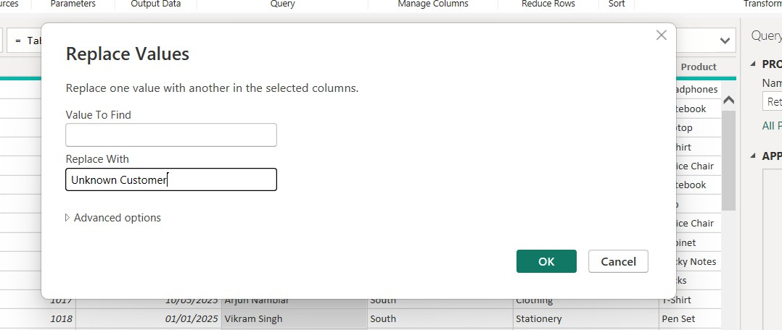

- Handle missing values in the Discount column. Replace null values with 0 using the Replace Values option. A value of 0 represents that no discount was applied when the discount information is missing.
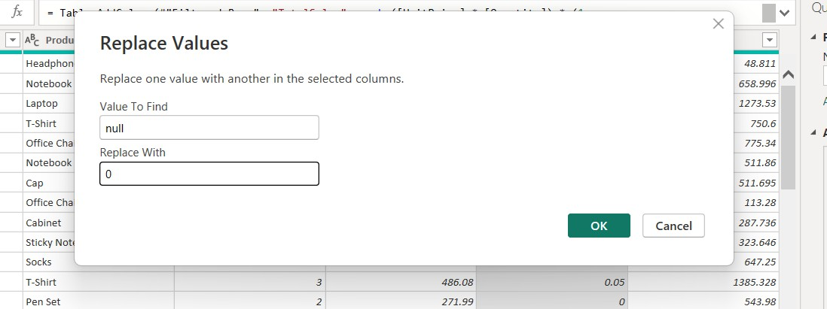

- Identify and remove invalid Quantity values. Select the Quantity column and apply a filter by pressing the arrow next to the column name to exclude records where Quantity is less than 0. Negative quantities are treated as invalid business data because a normal sales transaction cannot contain a negative quantity.
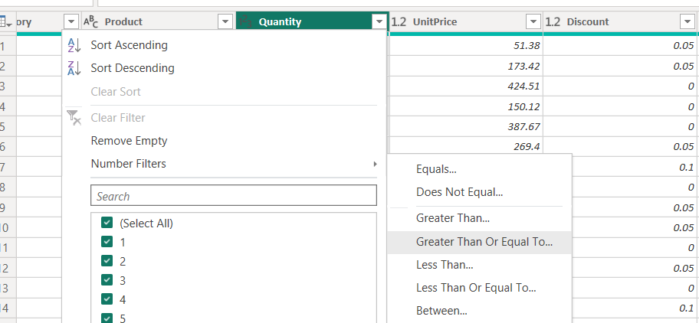
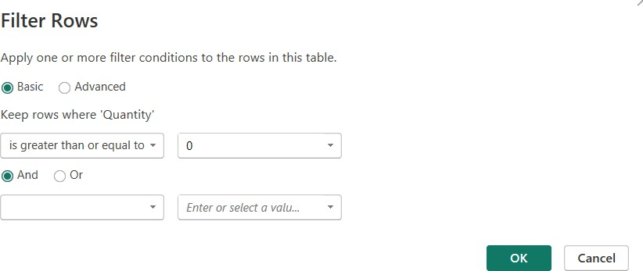

- Create a derived column for total sales. Select Add Column → Custom Column and name the new column TotalSales. Enter the formula ([UnitPrice] * [Quantity]) * (1 - [Discount]). This calculates the actual sales value after applying the discount.
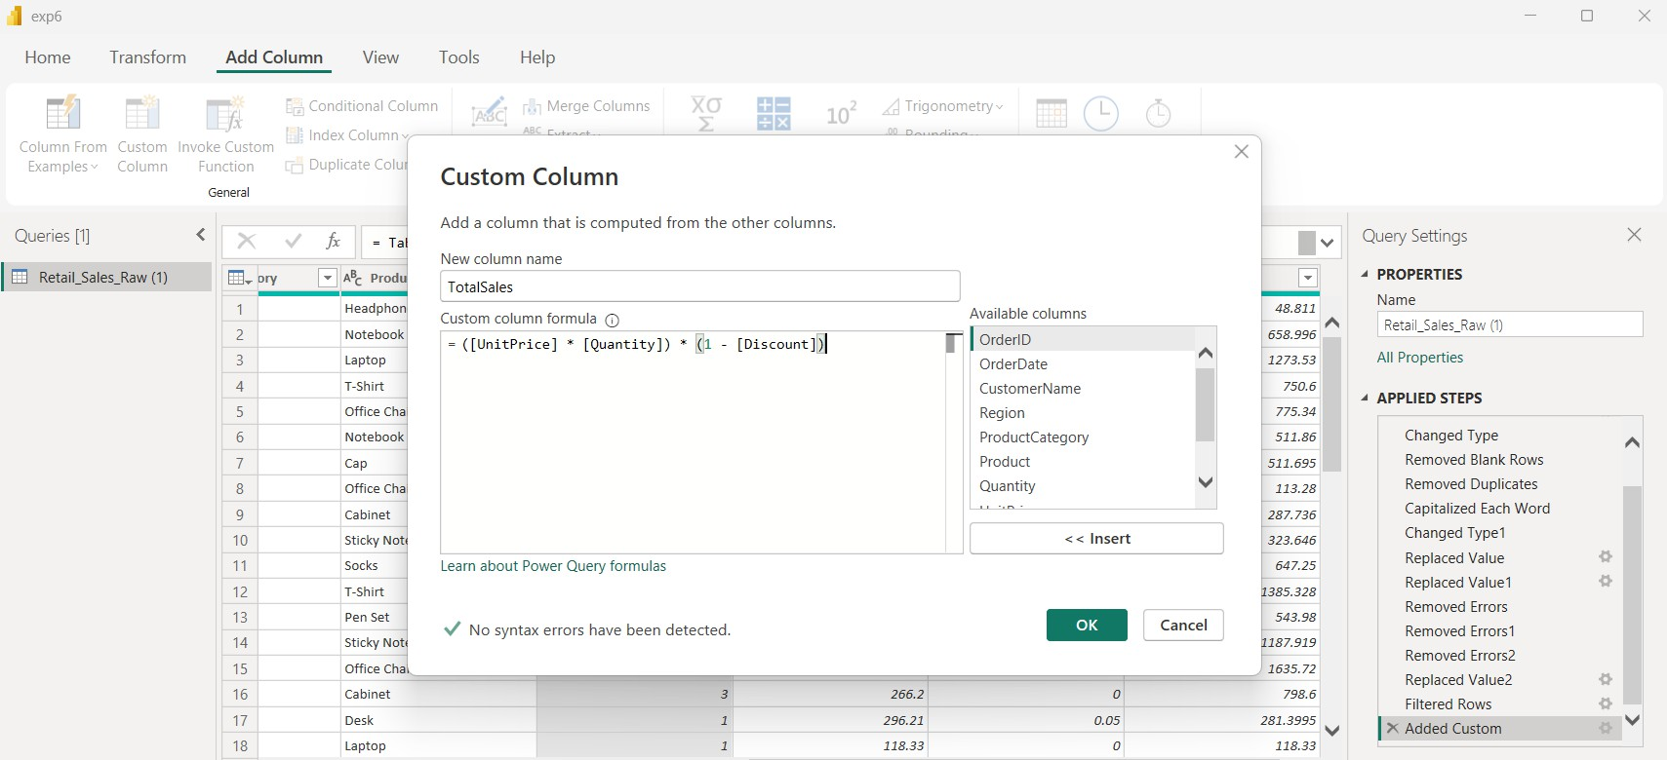

- Verify and correct the data types of all columns. Set OrderID to Whole Number, OrderDate to Date, Quantity to Whole Number, UnitPrice to Decimal Number, Discount to Decimal Number, TotalSales to Decimal Number, and the remaining descriptive columns to Text.
- Review the Applied Steps pane on the right side of the Power Query Editor. Confirm that all transformation steps have been recorded in the correct order. If an error is present, select the corresponding step and correct the transformation.
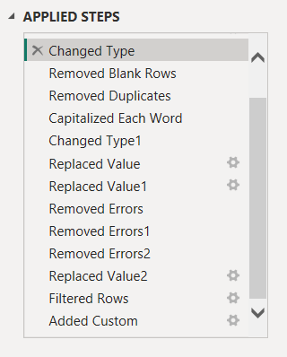

- After completing all cleaning and transformation operations, select Home → Close & Apply. Power BI will apply the transformations and load the cleaned data into the data model.
- Switch to the Data/Table view and inspect the transformed table. Verify that duplicate rows, blank rows, inconsistent Region values, invalid dates, missing customer names, missing discounts, and negative quantities have been handled correctly.

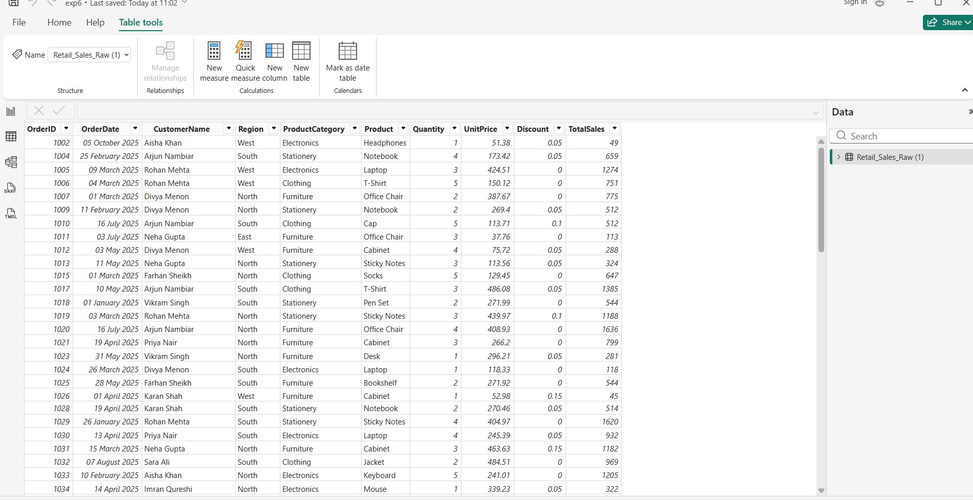

- To verify the ETL process visually, switch to Report view and create a Clustered Column Chart. Drag Region to the X- Axis field and TotalSales to the Y-axis field.
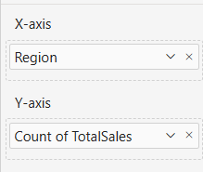

- Verify that the chart displays four standardized regions: North, South, East, and West. The resulting visual confirms that the data has been successfully extracted, transformed, and loaded into Power BI for further analysis.
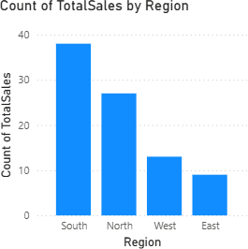

Interpretation:
South region generated highest sales East region generated lowest sales
ALGORITHM 3:

Creating a Bar Chart

Step 1 Choose Bar Chart Visualization
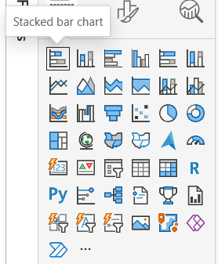

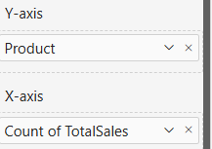
Step 2 Drag Product → Y-Axis Step 3 Drag TotalSales → X axis
Step 4 Format chart
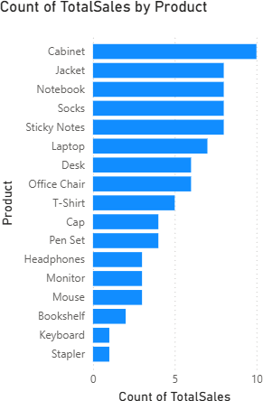

Interpretation:

Cabinet generated highest sales Stapler generated lowest sales

ALGORITHM 4:
Creating a Pie Chart
Step 1: Select Pie Chart
Step 2: Drag Product → Legend
Step 3: Drag Sales → Values
Step 4: Apply Data Labels
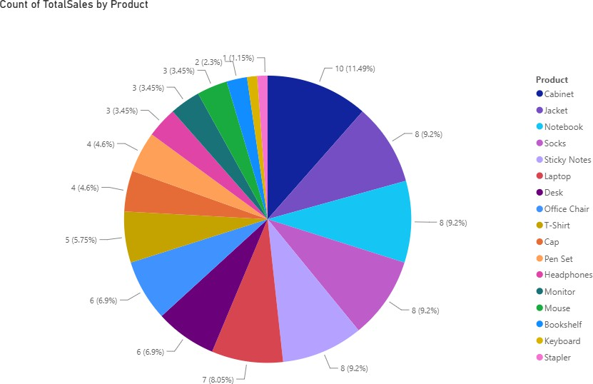

Interpretation:

Cabinet generated highest Sales with 11.49%

ALGORITHM 5
Creating a KPI Card
Step 1 Create 4 measures by clicking on the New Measure from Measure tools tab, type the formula inside the dax field:
- TotalSalesMeasure
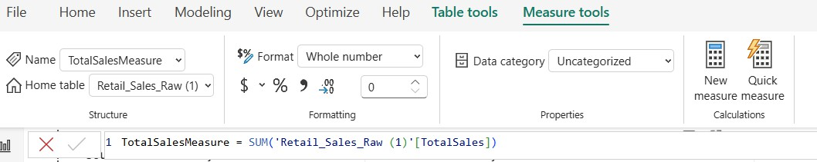

- Minimum
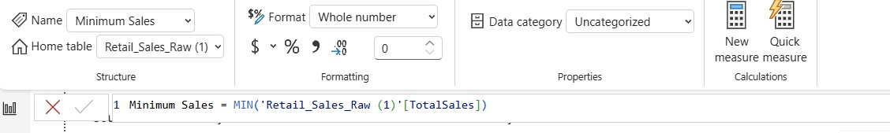

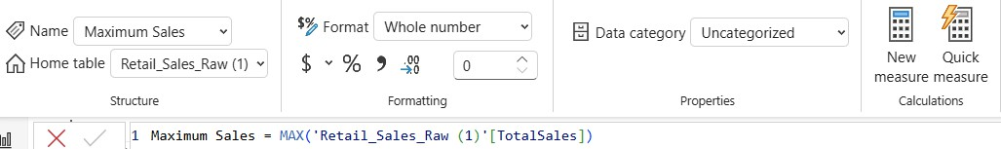
- Maximum

- Average
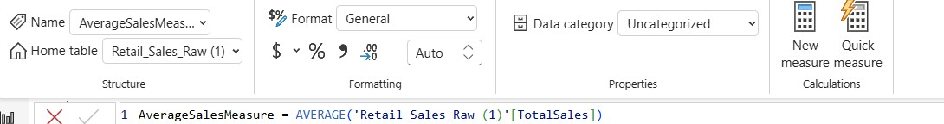

Step 2 Create card visual
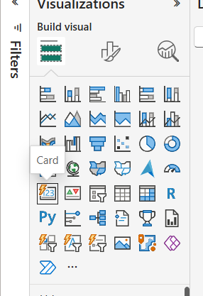

Step 3 Drag that measure into the field
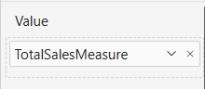

Output:
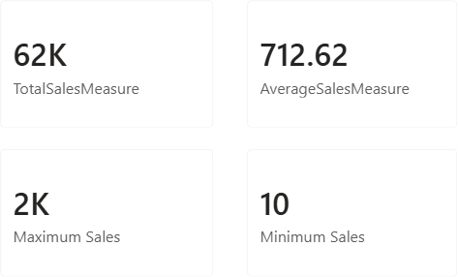
ALGORITHM 6:
Creating Slicers
Step 1: Select Slicer Visualization Step
Step 2: Drag Region Field
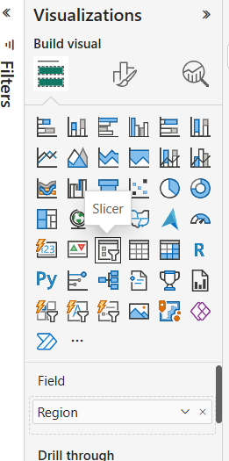
Step 3: Enable Single Selection
Step 4: Apply Filters

OUTPUT:
Without any filter:
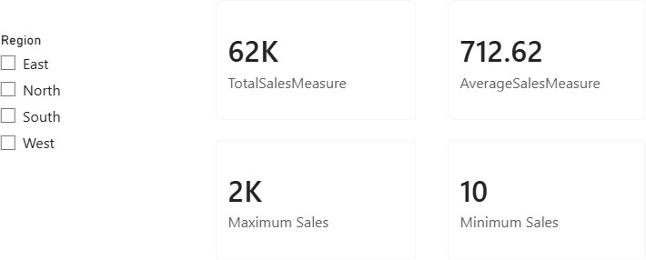

With north filter:
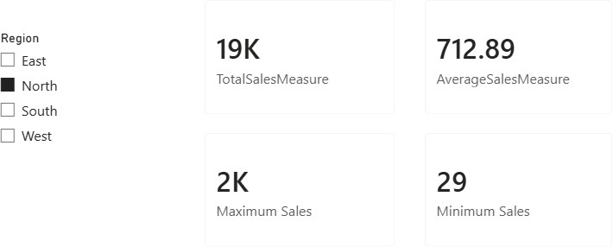
ALGORITHM 8:
Creating Dashboard
Step 1: Add KPI Card
Step 2: Add Bar Chart
Step 3: Add Pie Chart
Step 4: Add Slicer
Step 5: Arrange Visuals
Step 6: Save Dashboard

Dashboard Layout

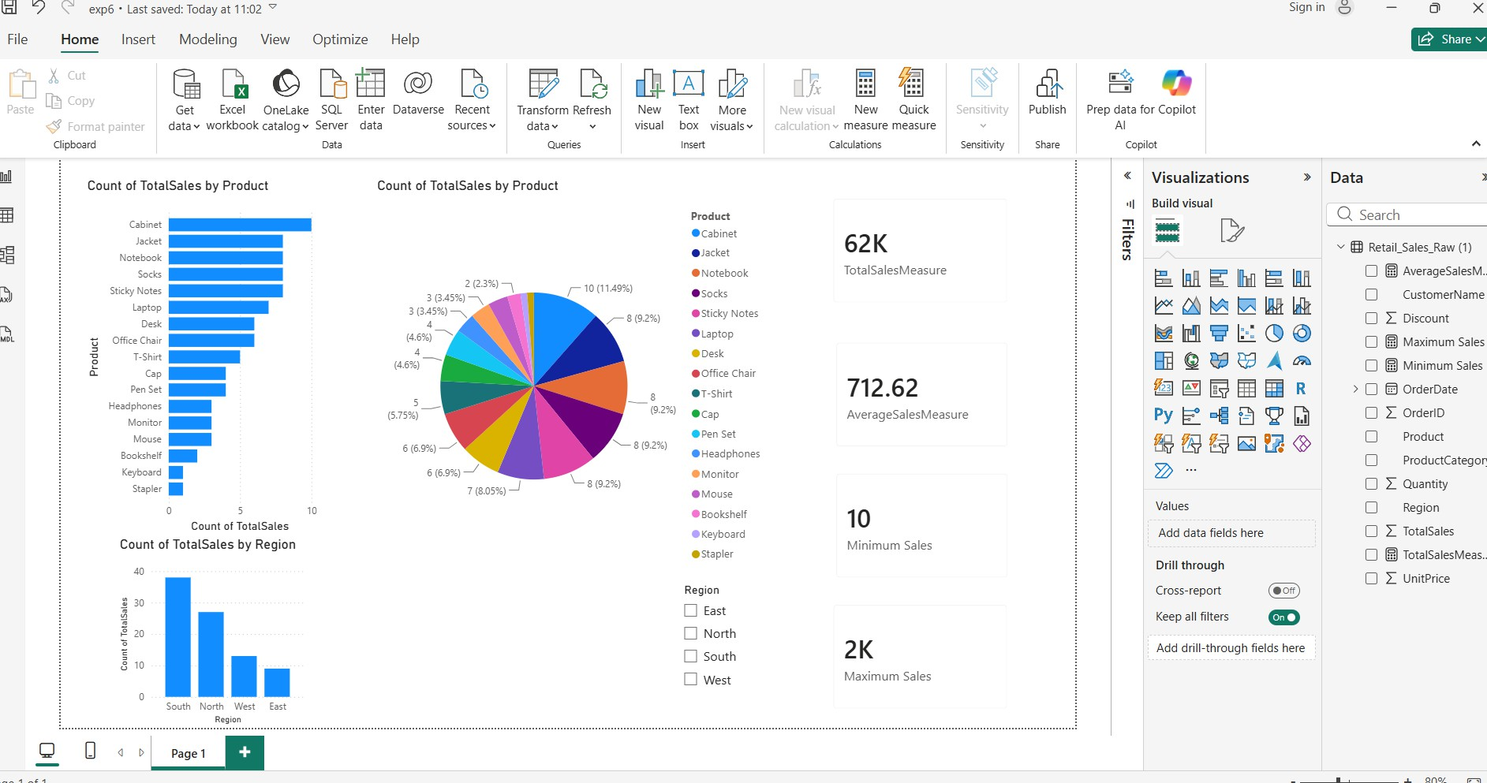

RESULT:
Thus, various visualization techniques such as Line Charts, Bar Charts, Pie Charts, Histograms, Scatter Plots, and Box Plots were successfully created using Matplotlib. The graphical representations helped in understanding trends, distributions, comparisons, and relationships within the dataset.

